Time Shift Alarm Setup Procedure
1. Unzip the Time Shift Alarm Fix.rar file.
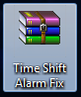
2. You will see there are three file in the folder.
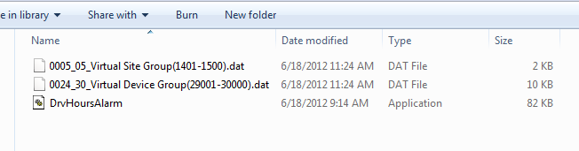
3. Copy this file "0024_30_Virtual Device Group(29001-30000).dat" to the following directory :
D:\CET\PecStar\devregs

4. Copy this file "0005_05_Virtual Site Group(1401-1500).dat" to the following directory :
D:\CET\PecStar\drvregs

5. Copy this file "DrvHoursAlarm.exe" to the following directory:
D:\CET\PecStar

6. After copy those files into the corresponding directory, you can move to next step. Import the driver into the PecStar System. Open the program "SystemRegistryImporter" which should located in the directory " D:\CET\PecStar"
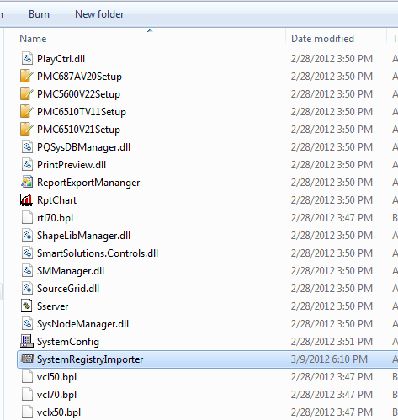
7. Once you double click the icon the following window will appear. Click the Tap "Driver Types"
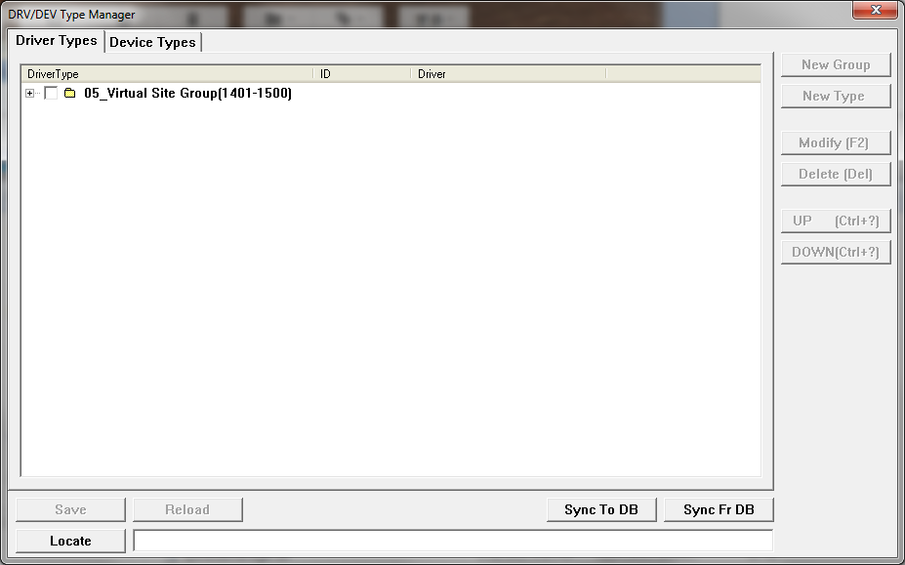
8. Select " Time Shift Alarm Driver" in the List and then press "Sync to DB"
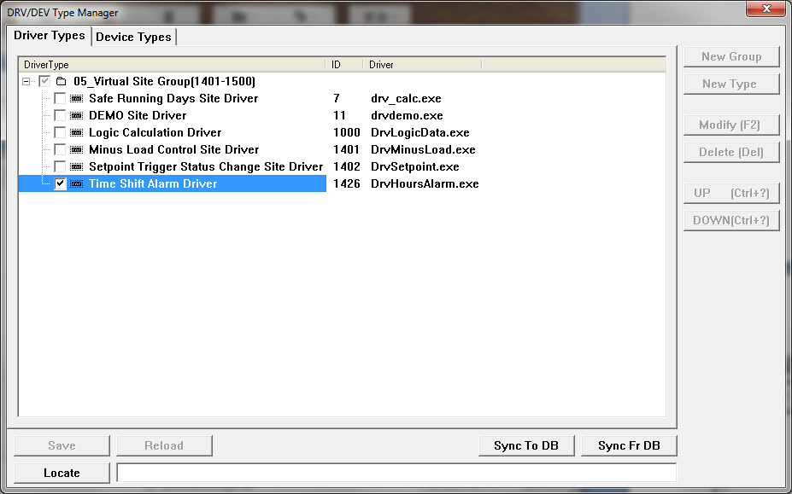
9. After press on "Sync to DB" button the following screen will appear. Select the "Time Shift Alarm Dirver" on the left hand side windows(Local) and press "Add" the driver will add to the Right hand side windows (Database). Press "OK" to complete the import action.
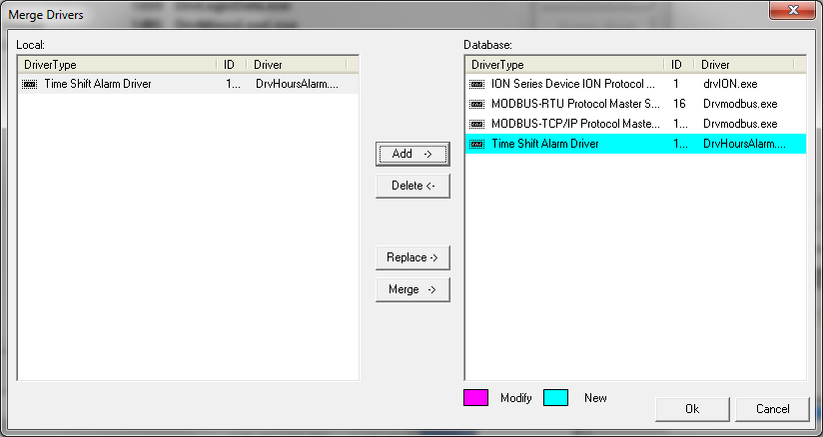
10. It will pop up a succeed message after you press "OK".
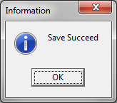
11. Press on the "Device Types" the following screen will appear.
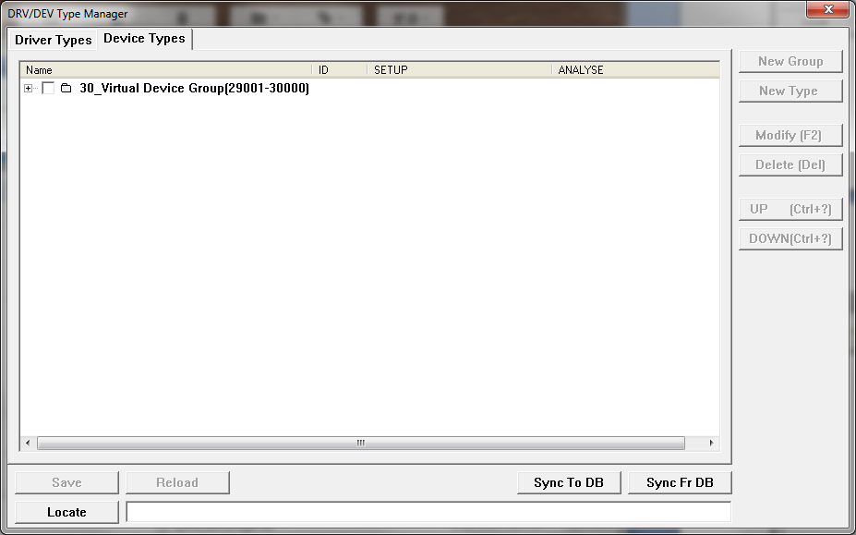
12. Select "Hours Alarm Meter" in the List and then press "Sync to DB"
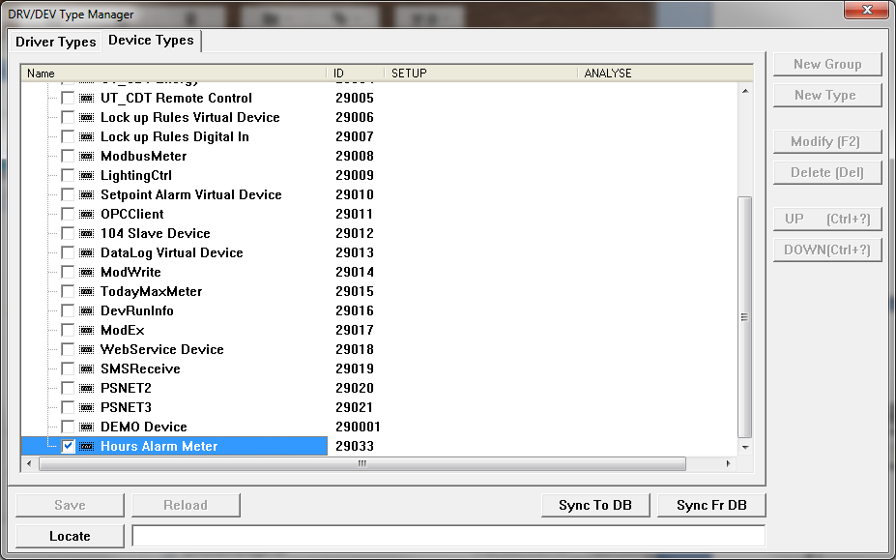
13. After press on "Sync to DB" button the following screen will appear. Select the "Hours Alarm Meter" on the left hand side windows(Local) and press "Add" the driver will add to the Right hand side windows (Database). Press "OK" to complete the import action.
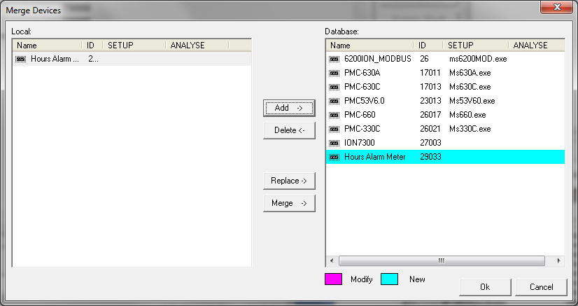
14. It will pop up a succeed message after you press "OK".
14. Open "PecConfig" to configure the alarm points.

15. Select "Display ID" under "View" Menu.
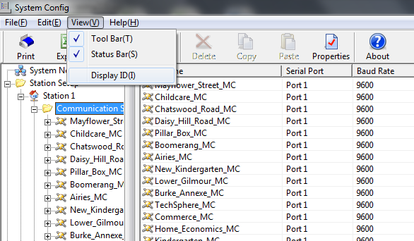
16. After Select "Display ID" the ID Column appear.
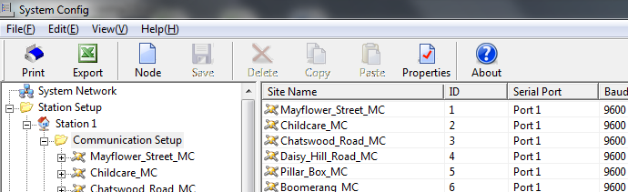
17. Add a New Side Node, by right click on the "Communication Setup" and select "New"
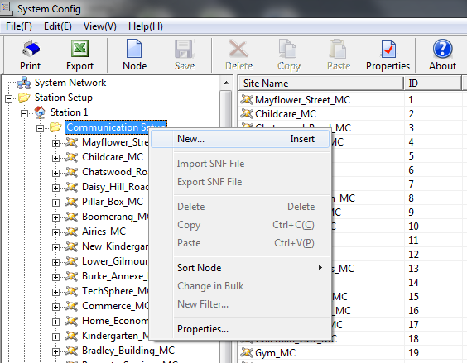
18. Enter the "Site Name " and select "Driver Type" as "Time Shift Alarm Driver" and then Press "OK"
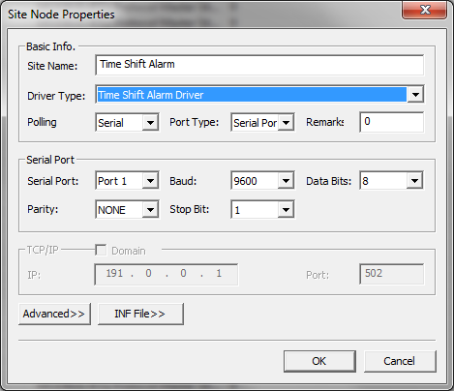
19. The "Time Shift Alarm" site is added in the list. Right click on the "Time Shift Alarm " site to addd a new device.
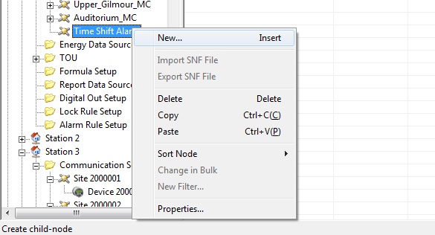
20. Enter the "Name " and select "Type" as "Hours Alarm Meter" and then Press "OK"
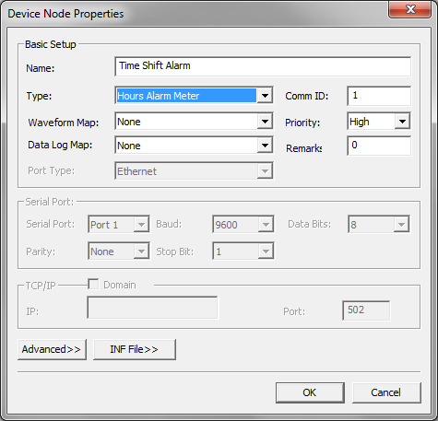
21. Right click the added Device and select "Properties. The following window will appear and press "INF File>>"
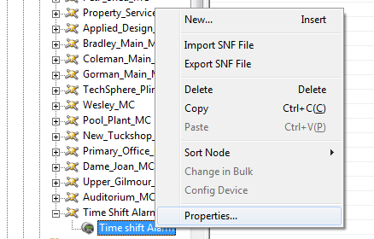
22. The following windows is using to config the Time period and the Alarm Point. Please refer to the attached excel file " Time Shift Alarm INF Template"
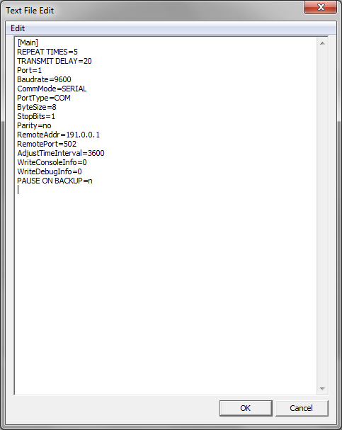
23 . The hightlighted part is Alarm point setup statement. In this example two alarm is configured.
One for Mayflower kW and other is for Childcare.
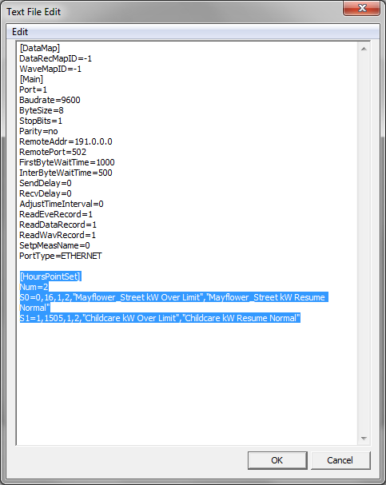
24. The hightlighted part is the time period setup statement. In this example two period configured.
The 1st time period is 00:00 to 11:59, The setpoint higher limit is 35kW and the lower limit is 30kW.
The 2nd time period is 12:00 to 23:59, The setpoint higher limit is 15kW and the lower limit is 10kW.
Press "OK" to complete the setup.
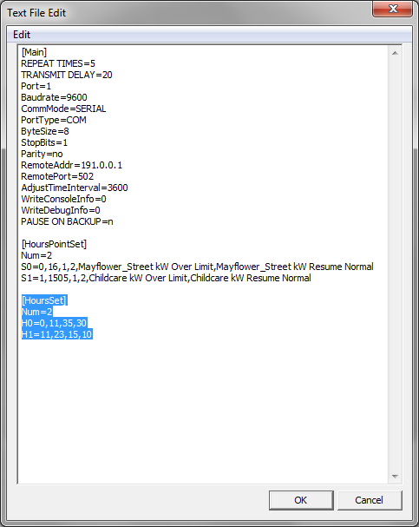
25. Remember to save the config in the database
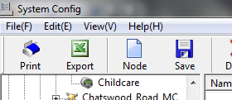
26. The following message box will appear
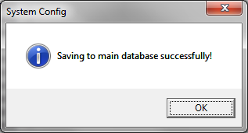
27. Open the PecSCADA to verify the setting.
